

Computer Games Development

Project Report

Year IV

Oisín Wilson

C00213826

[03/05/2020]

Faculty of ____IT CARLOW_____

Open-Book and Remote Assessment Cover Page

Student Name: Oisín Wilson

Student Number: C00213826

Lecturer Name: Oisín Cawley

Module: Final Year Project

Stage/Year: 4th Year

Date: 03/05/2020

Declaration

This examination/assessment will be submitted using Turnitin as the online submission tool. By submitting my examination/assessment to Turnitin, I am declaring that this examination/assessment is my own work. I understand that I may be required to orally defend any of my answers, to the lecturer, at a given time after the examination/assessment has been completed, as outlined in the student regulations.

**Contents**

**Acknowledgements** **2**

Abstract **3**

Project Introduction and Research Question **3**

**Background** **4**

Literature Review - (Not revised yet) **5**

Study **6**

Project Description **7**

Project Milestones **9**

**Results and Discussion** **9**

Project Review and Conclusions **10**

References - Not Done **12**

**Appendices - Not done** **13**

# Acknowledgements

I would like to thank all of the current and prior participants of the DESQOL Erasmus+ project for laying the groundwork and gathering a large body of information on coeliacs.

# Abstract

This project will be a study in colour psychology with technology and how it can influence the perceptions and enhance the effectiveness of applications within the context of behavior change.

# Project Introduction and Research Question

This project is one of three projects that all individually aim to create features for one collective mobile application, that aims to assist people who are suffering from celiacs disease. The overarching celiac app project was started last year by Dr Alfonso Rodriguez-Herrera and the IT-Carlow Erasmus+ team. Within this, the different parts of functionality for the app were split up and tasked amongst last year's members. This year we are building upon the work done from those past members by splitting up rolls just as they did. The segment I have been tasked with is the symptom tracker and information display, while my other co-students are working on A Quiz and A GIP Stick scanner.

I chose to undertake this project as I saw it as an exciting opportunity to partake in a multi country collaboration while simultaneously completing the requirements of my final year in Games Development. This project is to provide an application that persuades Celiac patients to perform a particular action, that being journaling their dietary habits and their symptoms. This is being done with the end goal of making the process of documenting a celiac’s symptoms and dietary intake more meaningful, habitual and enjoyable.

Research Question

“Can the use of colour within data presenting contribute to the behavior change?”

# 

# Background

This Project was started by Dr Alfonso Rodriguez-Herrera from St Luke's Hospital in Kilkenny and is going under the name of DESQOL. Which is a pseudo acronym for “Teaching Interdisciplinary Human Centered Design to Improve Patient Quality of Life”. With the assistance of IT Carlow and the Erasmus+ program, the project has grown and is currently being participated by people from:

* IT Carlow.
* St. Luke's Hospital Kilkenny, HSE.
* FHV, Vorarlberg University of Applied Sciences.
* HVA, Amsterdam.
* Grupo IHP, Andalucia, Spain.

Last year’s students laid down the groundwork in creating react web apps that fulfill their allocated fields respectively. This year we have been tasked with porting their work into mobile applications while improving upon their designs and functionality.

I have a small bit of experience working with Java, Javascript and SQL as they were languages touched upon within the Web Development & Databases module of last year. However I have no experience using React or React Native, which marks a significant learning in this project. I’ve also begun researching methods of displaying the information gathered by the app so that the user can easily see their health progress over time. I feel that giving the user an option to change the graph types from a line chart to a pie chart or even a spider chart as this will appeal to a wider audience.

# Literature Review

The "Combining UX Design And Psychology To Change User Behavior" article deep dives into the fundamental reasons behind what drives users to certain behaviors. It investigates the need to look at the psychology that underlies the process of initiating and performing a behavior. When understanding the broader mechanisms that guide actions we are able to create usable interfaces that changes users behaviour

Kintscher, N. (2016, January). Combining UX Design And Psychology To Change User Behavior. Retrieved from <https://www.smashingmagazine.com/2016/01/combining-ux-design-and-psychology-to-change-user-behavior/>

The main conclusions from the article “Cause and Effect – Exploring Color Psychology” is that color plays a vital part of creating positive user experiences and that there is no single right color palette for a given application. This is why testing designs with real users is such a vital part of creating a color palette optimized for the specific use cases it will be enduring. For example a green button might convert great compared to a yellow button in one context, but a red button might outperform them both in another. Context and experience are key s attributes to driving user behavior

Chapman, C. (2019, March).Cause and Effect – Exploring Color Psychology. Retrieved from <https://www.toptal.com/designers/ux/color-psychology>

# Study

The research question I’m trying to answer is, “Can the use of colour within data presenting contribute to the behavior change?” In order to test this idea, I’m going to utilize a testing study that the IT Carlow health students are organizing where a selection of celiac patients will be asked to partake in two 21 day challenges. They will be challenged to use the Eurasums collective app for 21 days and then fill out a survey providing feedback on how helpful it was and what improvements would be desired.

With the first version of the test app I plan to include the first version of my data display component and with the survey. I also plan to include questions to the users, asking them the level of importance of displaying their symptoms, displaying their diet and the need for notification reminders.

In the second instance of the 21 day challenge I plan to implement in the test app my colour idea by randomly distributing one of three colour variants of a data display. The purpose of which I can document the effectiveness of the palettes and find if there is a relation to the behavioural change over time with that colour palette.

This will be done by having three palettes, one a selection of greys, the other a selection of complementary colours and the last a selection of contrasting colours. By having the three palettes I can compare how often the user journaled their diet using the app. With that data I can examine the users diet and symptom data to examine any positive trends and analyze if there was any correlation to the colour choice in the display types.

# Project Description

The goal for my finished product is to have a collection of components that can be put into applications with the intent of positive behavior change. My intended components are:

* Switchable Data Display component.
* Calendar component.
* Input component.
* Barcode scanner component.

I will be adding my created display type called Circle View to the main application. This display type mashes two properties together in a unique way. Those properties being a progress bar and a calendar. This view Utilizes a circular progress bar that will be representative of the monthly progress. Within this bar there will be small circles that represent each day that has passed in the month. Those circles will be the appropriate colour to what kind of inputs were done on that day. This display type will be tested in the first 21 Day challenge and all going well,this will be used in the colour palette test in the second 21 Day challenge.

To obtain data from the user I will be incorporating an input screen, where the user will have a selection of input types to expand the level of data that can be recorded. The selection will include :

* Mood
  + Terrible
  + Poor
  + Just ok
  + Good
  + Great
* Gluten
  + yes
  + no
* Meal
  + Breakfast
  + Snack
  + Lunch
  + Tea
  + Dinner
* Symptoms
  + Diarrhea
  + Stomachache
  + Headache
  + Fatigue
  + Irritability
  + Vomiting
  + Rash
  + Weight loss

The symptom selection will be a multiple selection and the rest will be a singular selection. All of the inputs selected from this screen will be stored within a locally created SQL database on their mobile device.

For comparative purposes, I will incorporate a standard calendar into the app that will be used to bluntly display the data as a list to the user, thus giving them more options of reading their inputed data.

To make the data input more convenient the user should have the option to scan the barcodes of food to save them the time of typing out a lengthy product name.

# Project Milestones

7th Oct: Project approval

14th Oct: Begin sprint 1

11th Nov: Submit Research Document

18th Nov: Begin Sprint 2

9th Dec: Submit SRS and TDD along side a Code Demo

6th Jan: Begin sprint 3

9th Mar: Begin sprint 4

30th Apr: Present Project

# Results and Discussion

Due to the covid-19 pandemic only the first wave of two 21 day challenges were completed, leaving the dataset incomplete.

However with this limited data set and the completed survey, the users were asked to include what they would consider the most important needs of the App was to them. A consensus showed a visual connection between diet and symptoms isn’t a want, but a need from the celiac users. This means that using display designs that heavily utilize colour psychology should create a UX that manifests an underlying association of colour to action, thus reinforcing the desired behavior.

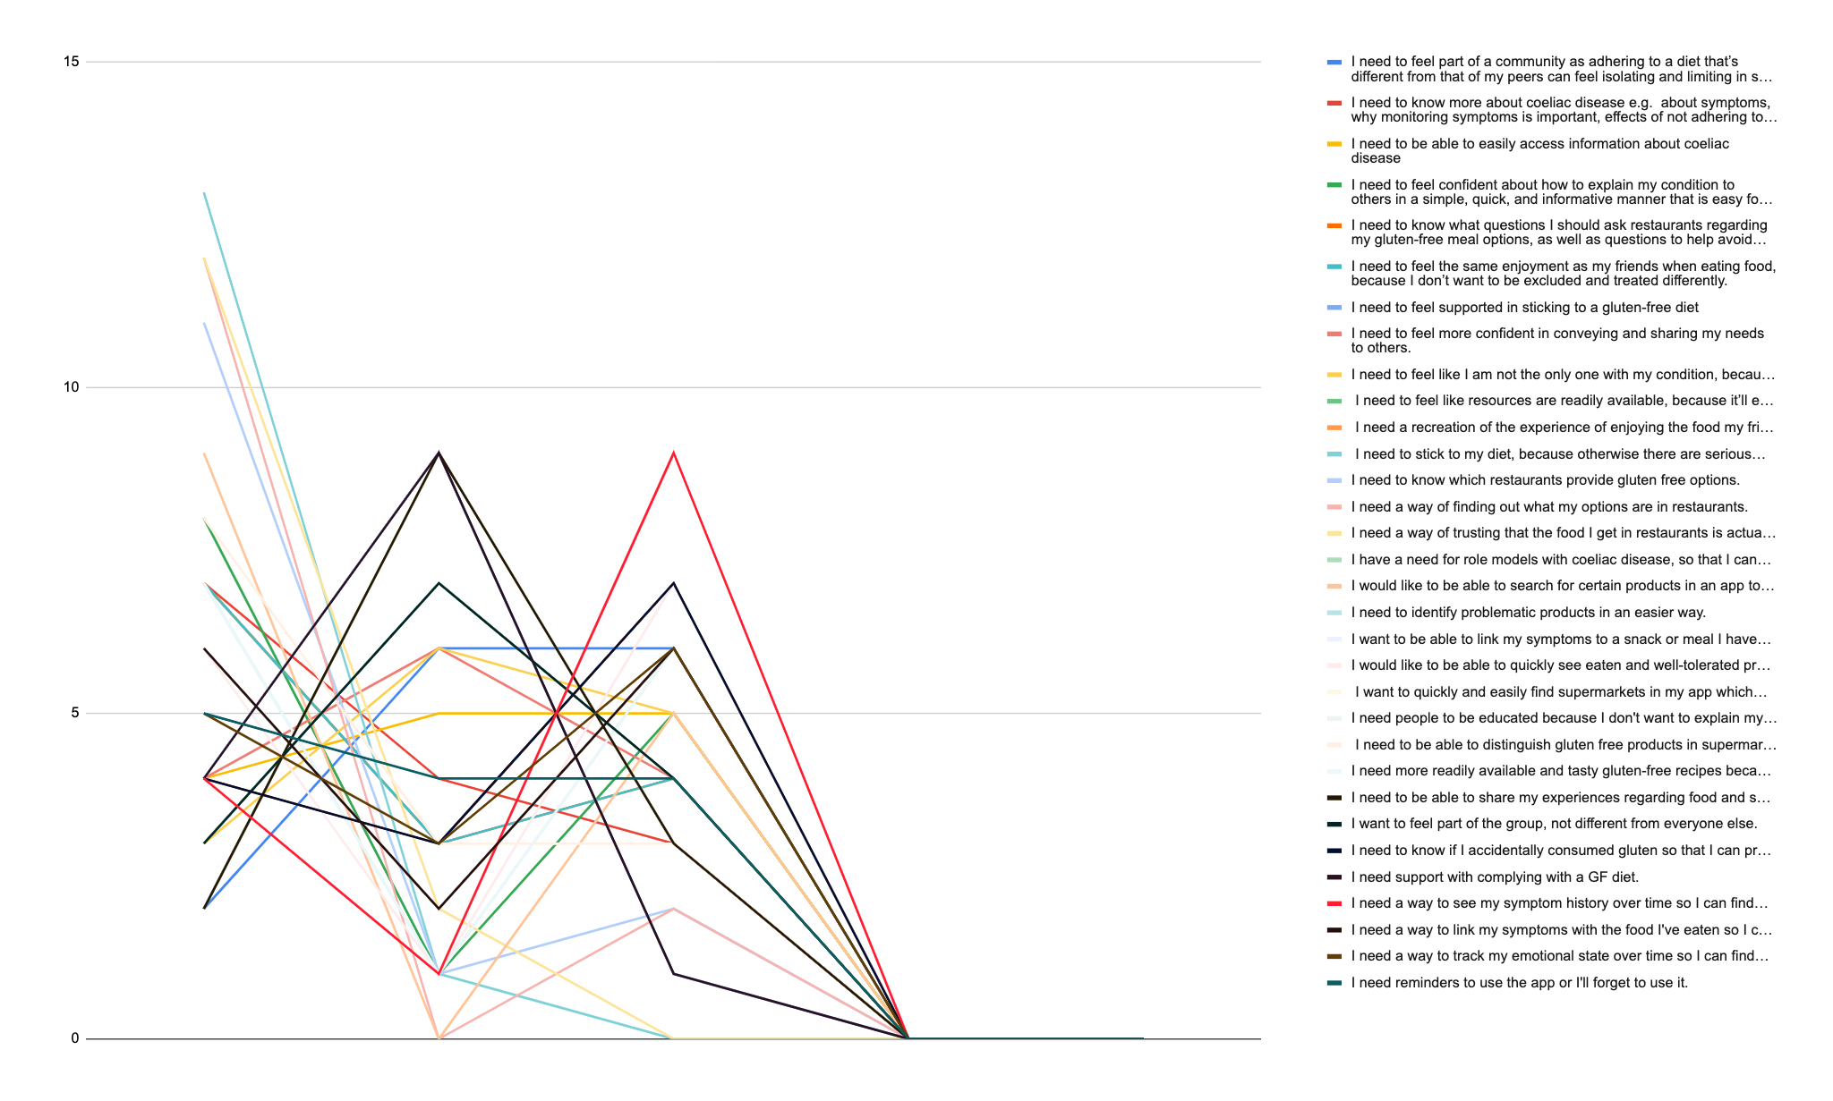

# Project Review and Conclusions

Coming from a C++ background, I found that React Native had a steep learning curve throughout the entirety of the project. I found using the framework to be very productive but when there were issues, it was very hard to debug due to being quite abstracted from the underlying code.

This can be a common problem with using frameworks.

Although from a functionality standpoint React Native was an excellent choice, as its ability to produce apps and components that can function on both IOS and Android speed up the development as a whole.

I am very happy with how my custom made display type (The Circle View) turned out in the end as it manages to fulfill the role of a mini calendar, while showing the user a brief history of what they have entered.

I believe the use of Expo during this project drastically helped development, as it has premade permission libraries that assists with accessing aspects of the phone. Especially the camera and without it I would not have been able to get a working barcode scanner in the project.

The most complex aspect for me during this project was creating a REST API. It serves as an Out-of-App notification manager that can send messages to a user’s phone, even if the main app is closed. I haven't created a REST API before and it was a foreign concept for me to wrap my head around. The networking aspect of it was especially challenging.

A primary issue I had over the duration of the project was sending push notifications to Android as it was more problematic than its IOS counterpart. Ultimately it had to be dropped from the Android App due to time restraints. I also would’ve liked to have created more display types to be tested in the second 21 day challenge but that never came to fruition.

Unfortunately the covid-19 outbreak reduced the amount of testing that could be done, as the 21 day challenge was being arranged by St. Luke’s hospital. They redirected all of their resources to deal with the pandemic.

If I were to do this project again, I would try to incorporate gamification into the data input and display, as I feel that it would elevate the overall engagement and increase the chances of reinforcing dietary awareness.

# References

* Kintscher, N. (2016, January). Combining UX Design And Psychology To Change User Behavior. Retrieved from <https://www.smashingmagazine.com/2016/01/combining-ux-design-and-psychology-to-change-user-behavior/>
* Chapman, C. (2019, March).Cause and Effect – Exploring Color Psychology. Retrieved from <https://www.toptal.com/designers/ux/color-psychology>
* React Native: <https://reactnative.dev/docs/getting-started>
* React: <https://reactjs.org>
* JavaScript: <https://www.w3schools.com/js/>
* SQLite: <https://www.sqlite.org/index.html>
* Apache Tomcat: <http://tomcat.apache.org>
* Java: <https://www.oracle.com/java/technologies/javase-downloads.html>
* Jersey: <https://eclipse-ee4j.github.io/jersey/>
* Apache Http Client: <https://hc.apache.org/httpcomponents-client-ga/>
* Firebase Cloud Messaging: <https://firebase.google.com/docs/cloud-messaging>

# 